# Topic: 1-bit sliding protocol

**Objective:**

Implementing One bit sliding window protocol. It is based on the concept of sliding window protocol. But here the window size is of 1 bit.

**Problem Statement:**

In one – bit sliding window protocol, the size of the window is 1. So the sender transmits a frame, waits for its acknowledgment, then transmits the next frame. Thus, it uses the concept of stop and waits for the protocol. This protocol provides for full – duplex communications. Hence, the acknowledgment is attached along with the next data frame to be sent by piggybacking.

**Algorithm:**

One bit sliding window protocol is based on the concept of sliding window protocol. But here the window size is of 1 bit.

* One bit sliding window protocol is used for delivery of data frames.
* Sender has sending window.
* Receiver has receiving window.
* Sending and receiving windows act as buffer storage.
* Here size of windows size is 1.
* One bit sliding window protocol uses Stop and Wait.
* Sender transmits a frame with sequence number.
* Then sender wait for acknowledgment from the receiver.
* Receiver send back an acknowledgement with sequence number.
* If sequence number of acknowledgement matches with sequence number of frame.
* Sender transmits the next frame.
* Else sender re-transmits the previous frame.
* Its bidirectional protocol.

**Code:**

#include<stdio.h>

int main()

{

int w,i,f,frames[50];

printf("Enter window size: ");

scanf("%d",&w);

printf("\nEnter number of frames to transmit: ");

scanf("%d",&f);

printf("\nEnter %d frames: ",f);

for(i=1;i<=f;i++)

scanf("%d",&frames[i]);

printf("\nWith sliding window protocol the frames will be sent in the following manner (assuming no corruption of frames)\n\n");

printf("Here window size is %d so, at each stage only %d frame is send and wait until Acknowledgement is sent by the receiver. \n\n",w,w);

for(i=1;i<=f;i++)

{

if(i%w==0)

{

printf("Frame no. %d\n",frames[i]);

printf("Acknowledgement is received\n\n");

}

else

printf("%d ",frames[i]);

}

if(f%w!=0)

printf("\nAcknowledgement of above frames sent is received by sender\n");

return 0;

}

**Output:**

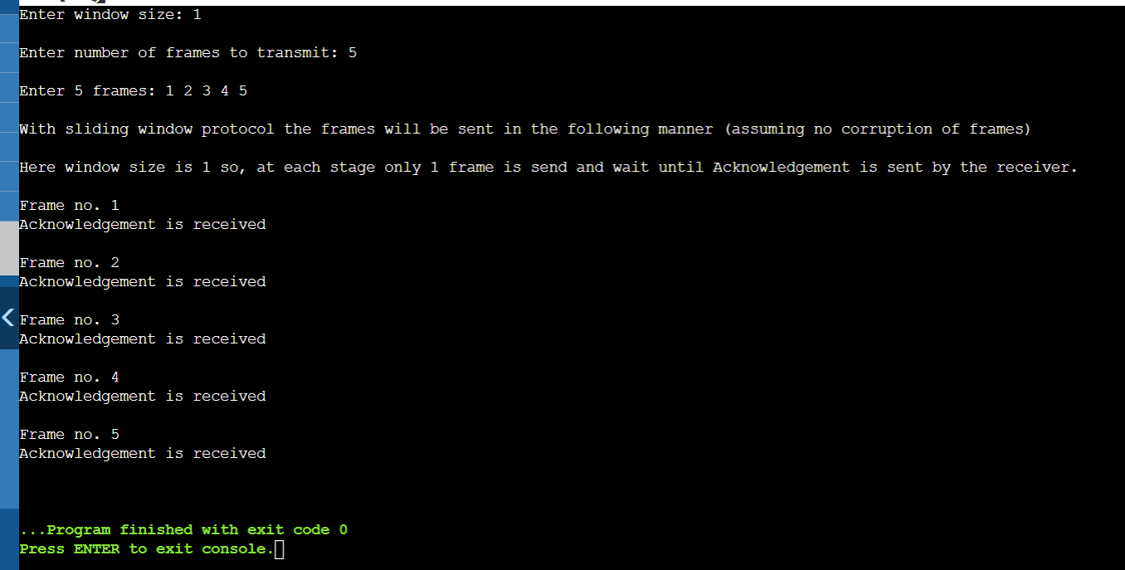

Here, as we know our window size is 1 so at each stage only 1 frame is transmitted. When 1 frame is sent, sender will wait until acknowledge is sent by the receiver and send next frame.

**Problems Faced:**

In this experiment, I didn’t face any problem. It is quite easy topic.

**Conclusion:**

With the help of this assignment, I understood the concept of One bit sliding window protocol.